**Detailed Guide to Applying for a Vietnam e-Visa on the Official Government Website: 2024 Edition**

Applying for a Vietnam e-Visa online is a straightforward process if you follow the correct steps. This guide will walk you through each step required to successfully apply for a Vietnam e-Visa on the official government website.

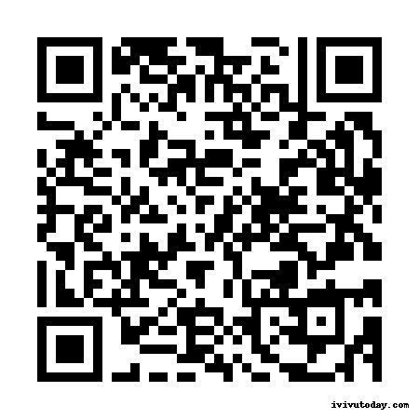

<https://ivivutoday.com/vietnam-visa-online-update/>

**1. Overview of the Vietnam e-Visa**

The Vietnam e-Visa is an electronic visa issued by the Vietnamese government, allowing travelers to apply online for a visa to enter Vietnam. This type of visa is suitable for short stays for purposes such as tourism, business, or family visits.

**1.1 Eligibility**

Citizens from over 80 countries can apply for a Vietnam e-Visa. Check the eligibility list on the official [Vietnam e-Visa website](https://evisa.xuatnhapcanh.gov.vn) to confirm if your country is included.

**1.2 Benefits**

* **Convenience**: Apply from anywhere with internet access.
* **Efficiency**: No need to visit an embassy or consulate.
* **Quick Processing**: Processing typically takes 3-5 working days.

**2. Detailed Steps to Apply for a Vietnam e-Visa**

**Step 1: Access the Official e-Visa Application Website**

1. Go to the official Vietnam e-Visa website: [evisa.xuatnhapcanh.gov.vn](https://evisa.xuatnhapcanh.gov.vn).
2. Click on “For Foreigners” to start the application process.

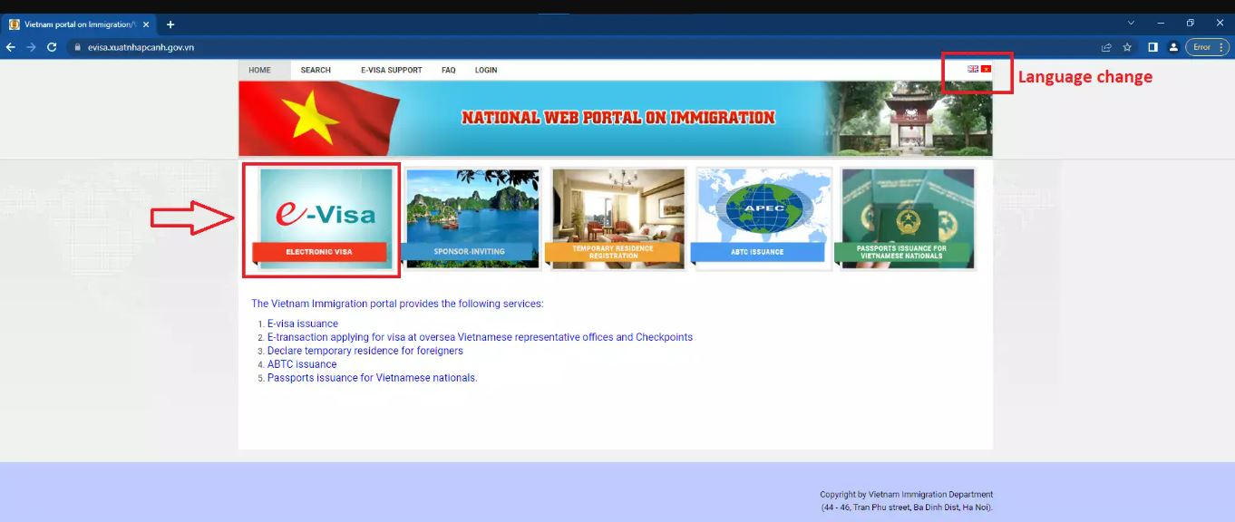

**Step 2: Start Your Application**

1. Click on “e-Visa Application” to begin.
2. Read the instructions carefully on the page that appears and click “Next” to proceed.

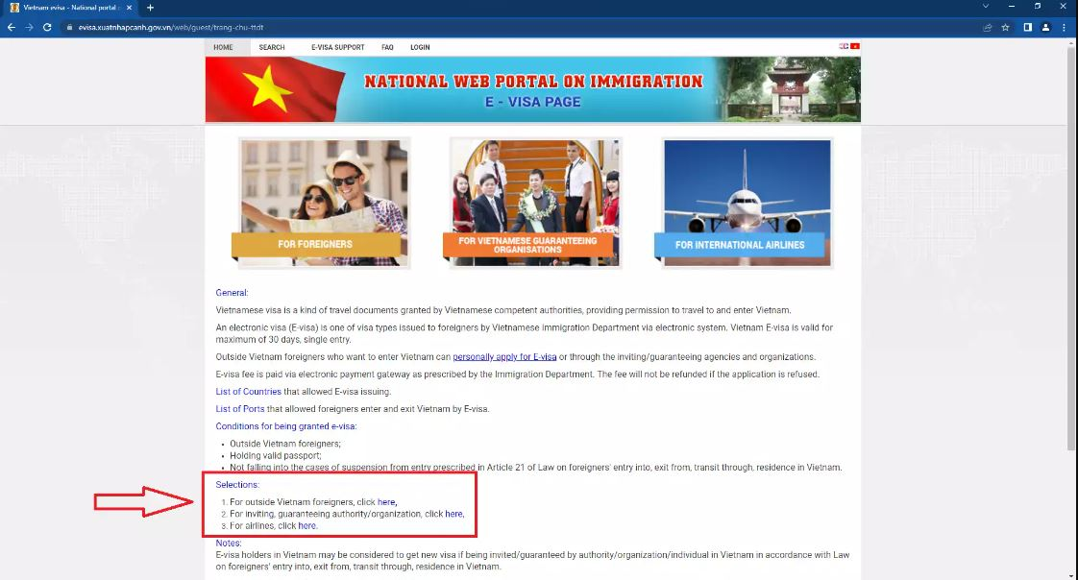

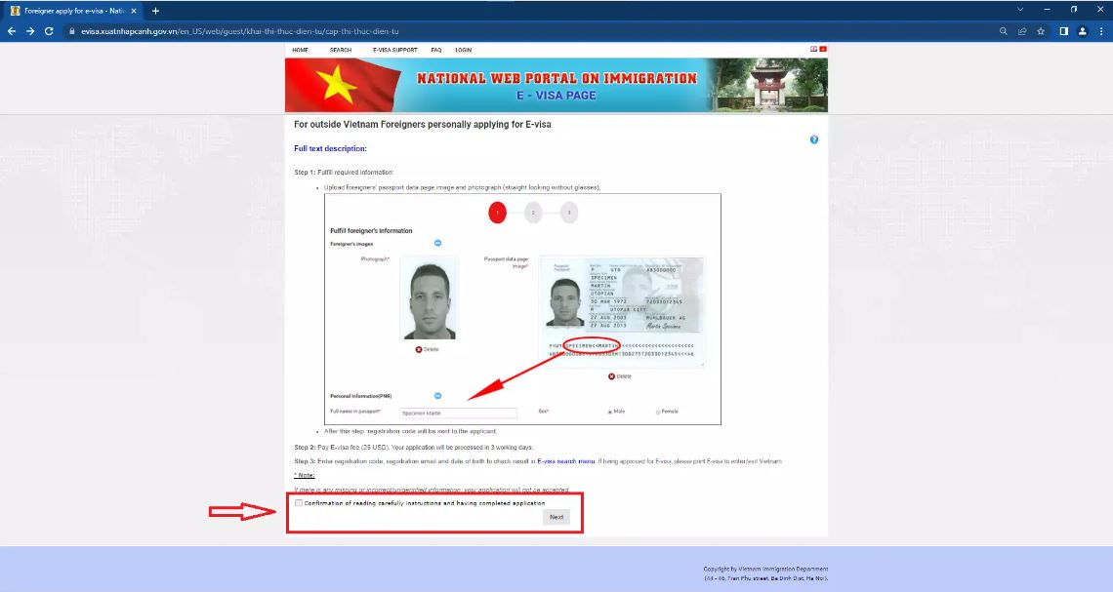

**Step 3: Fill Out the Application Form**

1. **Personal Information**:
   * Enter your full name exactly as it appears on your passport.
   * Provide your date of birth, nationality, and passport number.
   * Upload a recent passport-sized photo.

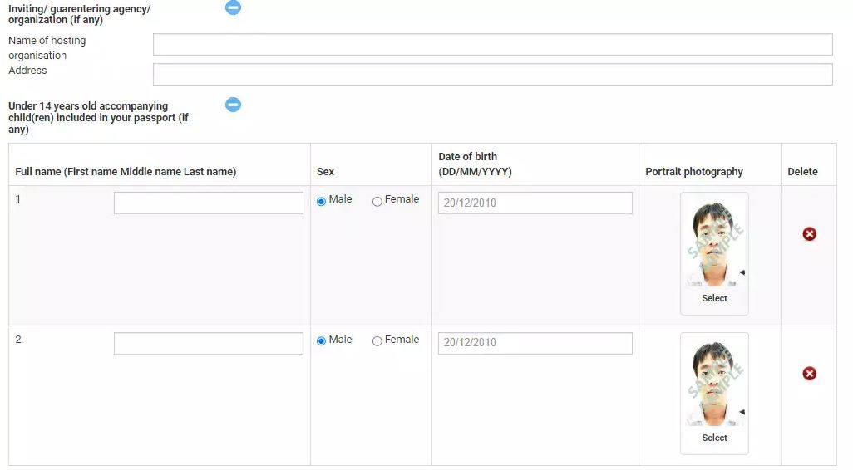

1. **Travel Information**:
   * Select the purpose of your visit (e.g., tourism, business).
   * Provide the address of your accommodation in Vietnam.
   * Enter your expected date of entry and port of entry into Vietnam.
2. **Supporting Documents**:
   * Upload a scanned copy of your passport’s biographical page.

**Step 4: Review Your Application**

1. Carefully review all the information you have entered.
2. Ensure that all details are accurate and match your passport.
3. Click “Confirm” to proceed.

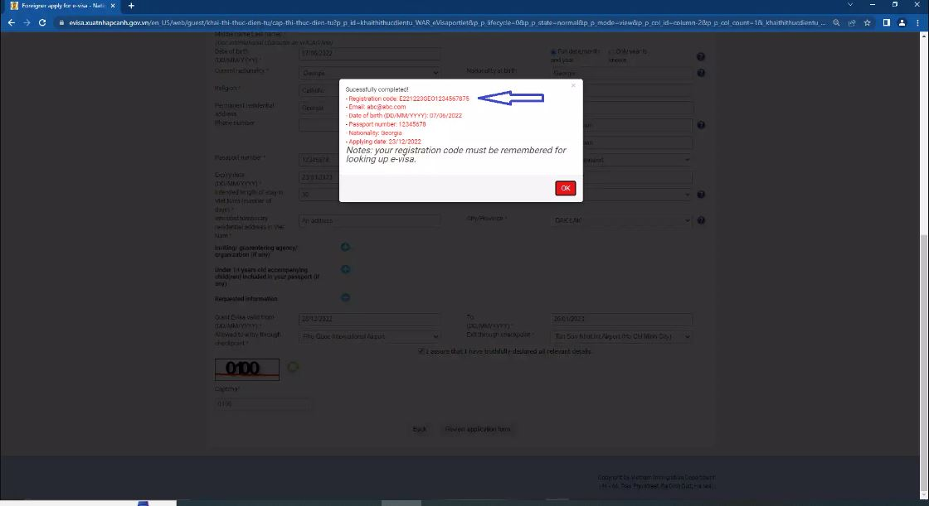

**Step 5: Pay the Visa Fee**

1. You will be redirected to the payment page.
2. Pay the visa processing fee using a valid credit or debit card.
3. The fee is typically non-refundable, so make sure your application details are correct before proceeding with payment.

**Step 6: Submit Your Application**

1. Once the payment is completed, submit your application.
2. You will receive an application code to track the status of your visa application.
3. Keep this code safe for future reference.

**Step 7: Check the Status of Your Application**

1. After 3-5 working days, visit the e-Visa status page on the official website.
2. Enter your application code and other required details to check the status of your visa.

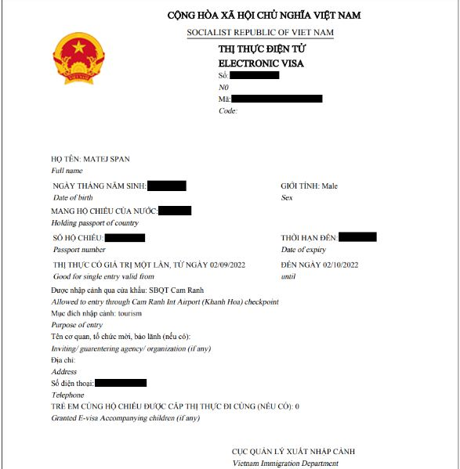

**Step 8: Download Your e-Visa**

1. Once your e-Visa is approved, download it from the official website.
2. Print at least two copies of your e-Visa.

**Step 9: Prepare for Your Trip to Vietnam**

1. **Documents to Carry**:
   * Printed e-Visa.
   * Valid passport.
   * Flight tickets.
   * Hotel reservation details.
2. **Arrival in Vietnam**:
   * Present your e-Visa, passport, and other documents at the immigration counter.
   * Ensure all your travel documents are easily accessible for inspection.

**3. Common Issues and Solutions in the e-Visa Application Process**

**3.1 Incomplete or Incorrect Documentation**

* **Problem**: Missing or incorrect documents can delay or result in visa rejection.
* **Solution**: Double-check all required documents before submission.

**3.2 Technical Issues During Application**

* **Problem**: Internet connectivity or website errors can disrupt the application process.
* **Solution**: Ensure a stable internet connection and use a compatible browser.

**3.3 Payment Issues**

* **Problem**: Payment may fail due to insufficient funds or bank restrictions.
* **Solution**: Verify your card details and ensure your bank allows international transactions.

**3.4 Rejected Applications**

* **Problem**: Applications may be rejected due to incorrect information or documentation.
* **Solution**: Carefully review the reasons for rejection and reapply with corrected information.

**4. Tips for a Successful e-Visa Application**

**4.1 Apply Early**

Apply at least two weeks before your planned travel date to allow time for processing and any potential issues.

**4.2 Ensure Accurate Information**

Ensure all information on your application matches your passport and travel documents exactly.

**4.3 Keep a Copy of Your e-Visa and Documents**

Print multiple copies of your e-Visa and other travel documents to carry with you during your trip.

**4.4 Seek Assistance if Needed**

If you encounter any difficulties, consider seeking help from a visa consultancy service or contacting the Vietnam Immigration Department.

**5. Frequently Asked Questions (FAQs)**

**5.1 How long does the e-Visa application process take?**

The processing time for a Vietnam e-Visa is typically 3-5 working days. Apply well in advance to accommodate any potential delays.

**5.2 Can I extend my e-Visa while in Vietnam?**

Currently, the Vietnam e-Visa cannot be extended. If you need to stay longer, you must apply for a different type of visa before your e-Visa expires.

**5.3 What should I do if my e-Visa application is rejected?**

If your e-Visa application is rejected, carefully review the reasons provided and correct any issues before reapplying. Seek assistance from the Vietnam Immigration Department for further guidance.

**5.4 Are there any visa exemptions for certain countries?**

Some countries have visa exemption agreements with Vietnam. Check the [Vietnam Visa Official Website](https://e-services.mps.gov.vn/bocongan/bothutuc/tthc?matt=26277) for the latest information on visa exemptions.

**5.5 Can I work in Vietnam with an e-Visa?**

No, the e-Visa is only valid for tourism, business meetings, or visiting family. You will need a specific work visa to engage in any employment activities in Vietnam.

**5.6 Is the Vietnam e-Visa valid for multiple entries?**

No, the Vietnam e-Visa is a single-entry visa and is valid for 30 days from the date of entry. For multiple entries, you will need to apply for a different visa type.

**5.7 What happens if I overstay my e-Visa in Vietnam?**

Overstaying your e-Visa can result in fines, penalties, and difficulties in obtaining future visas. It’s important to leave Vietnam before your e-Visa expires or apply for an extension if eligible.

**5.8 How can I contact the Vietnam Immigration Department for assistance?**

You can contact the Vietnam Immigration Department through their official website or visit the nearest immigration office for assistance.