**How to Fill out China Online Visa Application Form**

**Important: Save Application ID**

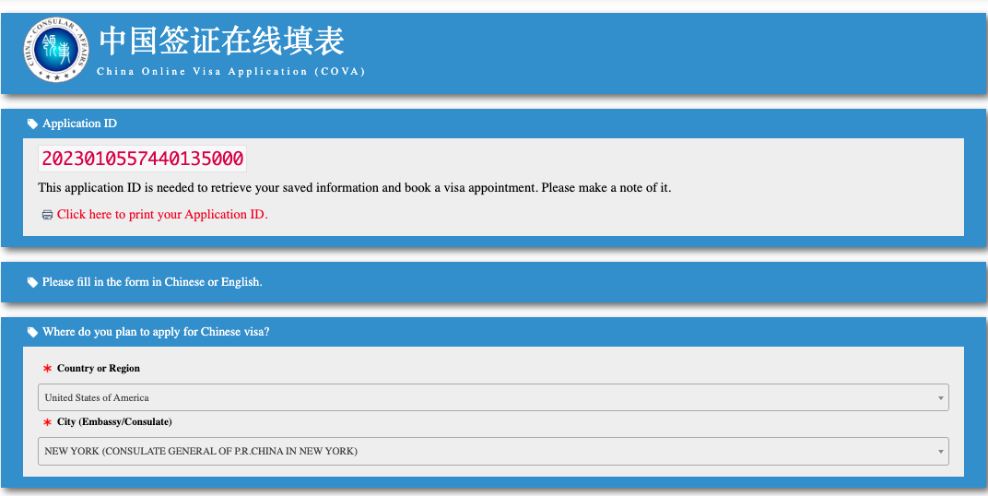

**Given Name should be first name + middle name as appear in your passport**

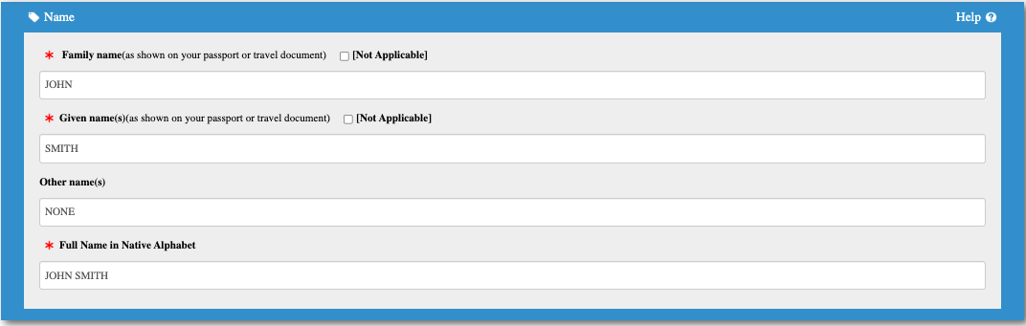

**Choose photo with pure white background to avoid upload problems.**

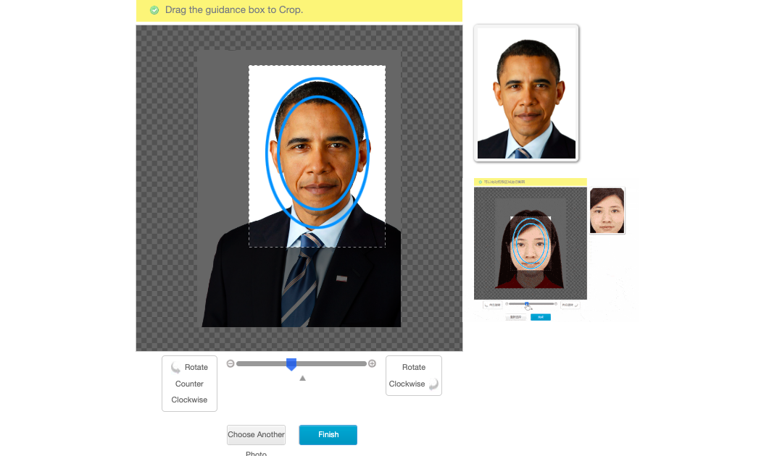

**Work experience (at least 5 years) is required. Highest education received is required.**

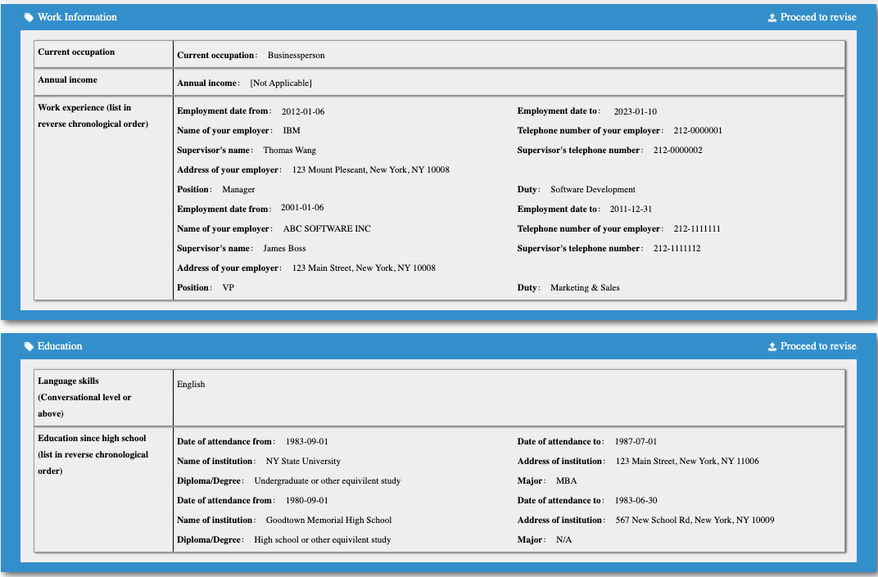

**This Section is a little tricky. Follow the sample.**

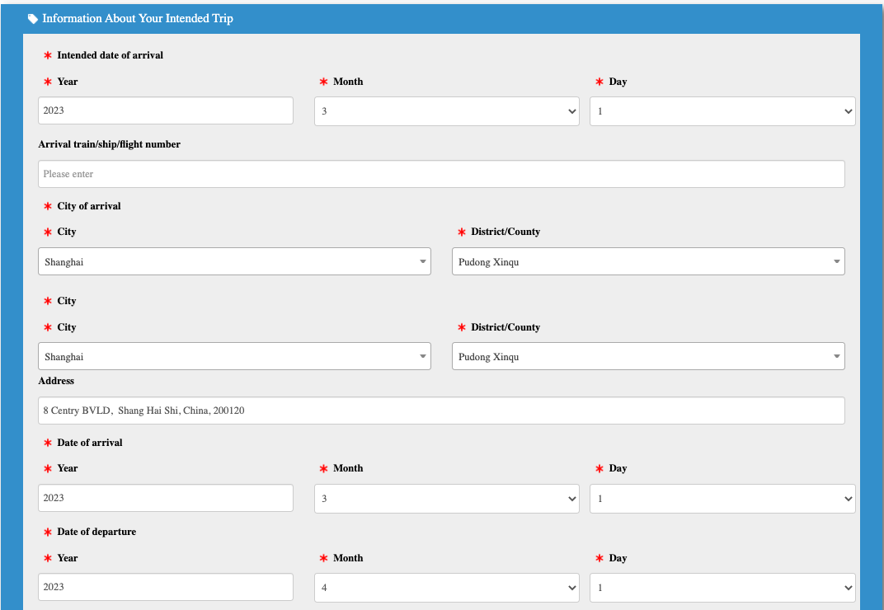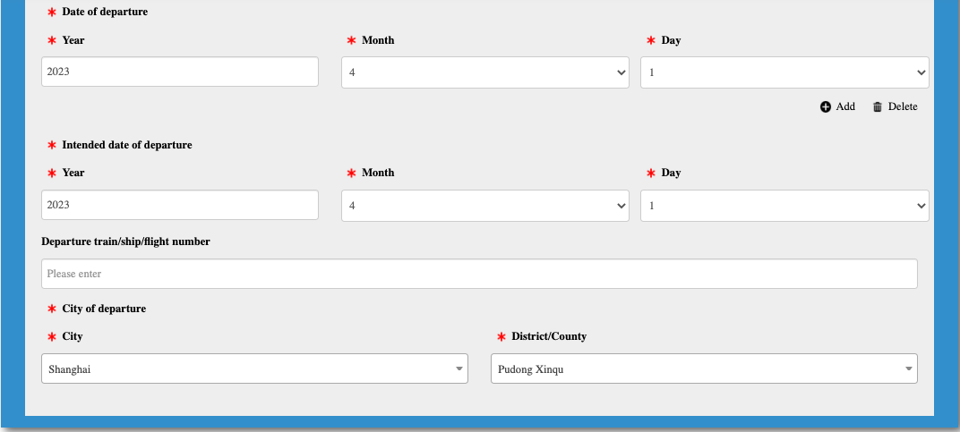

**After confirm, you won't be able to make any changes. Do not click Confirm and Next button, until we pre-check your application.**

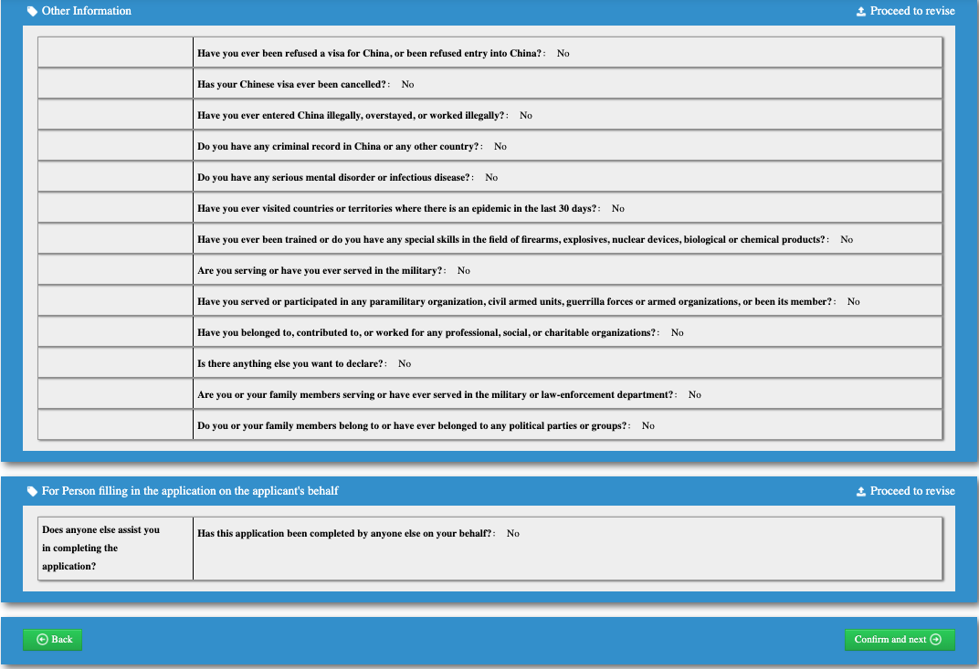

Please pay attention to the following:

* **Personal information**: Your name, gender, date of birth, nationality, passport number, etc. must match exactly those on the passport information page.
* **Given name**: Please note that in US passports, the middle name is part of Given names, and should be entered here exactly as shown in your US passport.
* **Other names**: Enter any other names you used, if you changed your name before.
* **Name as written in native language**: For Chinese descendants, write name in Chinese characters. For others, please write your full name here.
* **National ID number**: please use your driver's license number or passport number, not SSN.
* **Former nationality(ies):**If you are a naturalized citizen, enter your original citizenship here (e.g. China).
* **Visa details:** Enter 120 months for 10-year visa, and select Multiple Entries (For M, L, Q2, S2).
* **Work experience**
  + Provide work history after college, or at least recent 5 years.
  + The?**“position” and “duty”**?(form fields 3.3D and 3.3E) are needed, even though it shows optional online.
  + Phone number section: Enter 1 as country code for the US and 86 as country code for China. When you enter phone number, do not enter space or dash, enter only digits.
* **Education**
  + Highest education only.
  + **Major**?in 4.2D is needed.
* **Address**  
  The address of the spouse is asking for the current address, not the place of birth.
* **Parents**  
  For deceased parents, check "Not applicable", then enter "Deceased".
* **Phone Numbers**  
  Country code for USA is 001, Country code for China is 0086. When you enter the phone number, please do not type in space or dash. Enter the digits only.
* **Itinerary under information About Your Intended Trip:** Please enter the address in the city of your stay.
* **Accompanying person(s)**:  
  For US passport holder,**?**always answer No?(even for a baby).
* Sign and date?**on both the Confirmation Page and page 8**: must be handwritten by the applicant him/herself.
* Signatures for 18 or younger: sign by their guardian
  + Confirmation page: write child's name, then sign your name, then add (by mother or father)
  + Page 8: write child's name in the Applicant's signature, then sign your name in 9.1A, then add (by mother or father). You will need to complete 9.2A-D and sign your name in 9.2E.